FOR SALE – IMACC AEROBATIC RC AIRPLANE
(Plane Designed for IMACC Aerobatic Competition)
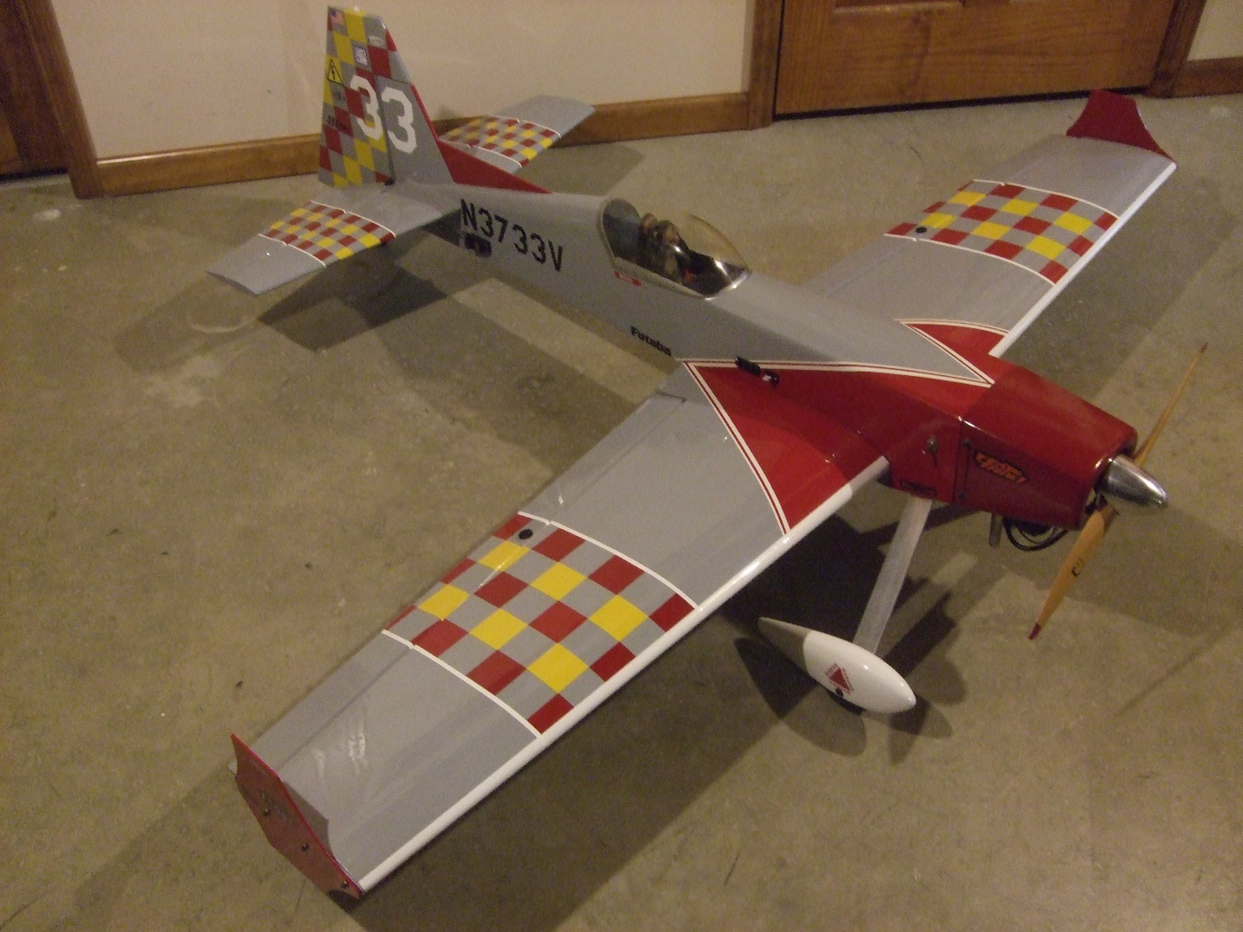
ENGINE SPECS: Mfr.: US Engines
Displacement – 41cc (2.5 cu-in)
Walbro Carb w/Velocity Stack
Ignition – Magneto w/Kill Switch
Prop - “XOAR” 18” x 10 Wood
Spinner – TruTurn Aluminum

PLANE SPECS: “KAOS” Airfoil, fully symmetrical
Wing tip side force generators “SFG”
Wing Span – 76 inches
Fuselage Length – 65 inches
Wing Area – 950 square inches
Total Weight – 15 lbs.
SERVOS INCLUDED:
Ailerons (qty 2) HiTec HS-635HB, 83oz-in @ 6vdc, Karbonite Gears
Elevators (qty 2) HiTec HS-635HB, 83oz-in @ 6vdc, Karbonite Gears
Rudder (qty 1) HiTec HS-755HB, 183oz-in @ 6vdc, Karbonite Gears
Throttle (qty 1) HiTec HS-325HP, 51oz-in @ 6vdc, Karbonite Gears

ADDITIONAL ITEMS INCLUDED:
- Heavy Duty High Tensile Strength Aluminum Landing Gear
- Heavy Duty Tail Wheel
- Rudder “Pull-Pull” Control
- Detailed Cockpit
- LiFe Rx Battery, 2s-6.6vdc-2200mah
- Heavy Duty Rx Switch
- Heavy Duty DuBro Control Arms and Servo Linkages
- Foam Core, balsa sheeted construction for wing, ailerons, stabilizer, elevator, fin, rudder, rear top of fuselage
- Engine Magneto “Kill Switch”
- Fiberglass Wheel Pants
- Spare set of Foam Cores for wing, stabilizer, elevator, fin, rudder and rear top of fuselage
- Airplane completely covered with “Top Flite Monokote”

EVERYTHING LISTED ABOVE FOR $400.00

CONTACT JIM MAUPIN FOR ANY QUESTIONS
- CELL # 513-256-7486 (call or text)
- Email: jempilot@comcast.net

